Welcome To
Trinity Lutheran Church
Lutheran Church—Missouri Synod
A Stephen Ministry Congregation

1354 South Otsego Avenue
Gaylord, Michigan 49735
Church Phone: (989) 732-4816

Church Email: secretary@trinitygaylord.com
www.trinitygaylord.com

Office Hours: Monday through Friday 9am – 1pm

OUR PURPOSE
…is to LOVE GOD, LOVE OTHERS, AND SERVE THE WORLD by worshiping the Lord Jesus, bringing our members into Christ-like maturity, and equipping them through Word and Sacrament for their mission and ministry. We go heart to heart into the world with Jesus, sharing His love, caring for one another, praying, and bringing the lost into a relationship with Christ, by the working of the Holy Spirit.

August 28, 2022
Twelfth Sunday after Pentecost
Preacher: Rev. Ken Bernthal

ABOUT OUR WORSHIP
We welcome all who gather here today! We are blessed to celebrate together the mercy, grace, and love we have from God through the death and resurrection of our Lord Jesus Christ.

Children: Families with children are very welcome here. Having children in church is important so they can begin to learn about their faith in Jesus, and it’s good for the whole congregation to see. Please feel comfortable keeping “squirmy” kids in the service. This is where they belong, too!

Pew Cards: Guests and Members, please fill out the Guest/Member card located on the back of the pew in front of you and pass it to the end of the aisle. If you forget you can put it in the offering plate on your way out.

If standing is difficult: Please feel free to remain seated during any portion of the service. Please let an Elder or Usher know if you need communion in your pew seat.

About our celebration of Holy Communion: We celebrate the Lord’s Supper in the confession and glad confidence that, as he says, our Lord gives into our mouths not only bread and wine but his very body and blood to eat and to drink for the forgiveness of sins and to strengthen our union with him and with one another. Our Lord invites to his table those who trust his words, repent of all sin, and set aside any refusal to forgive and love as he forgives and loves us, that they may show forth his death until he comes.

Because those who eat and drink our Lord’s body and blood contrary to that which is stated above do so to their great harm, and also because Holy Communion is a confession of the faith which is confessed at this altar. Anyone who is not yet instructed, in doubt, or who hold a confession differing from that of the Lutheran Church—Missouri Synod, and yet desire to receive the sacrament, are asked first to speak with Pastor. Those not communing are still invited to come forward for a blessing from Pastor, and you may indicate this by crossing your arms over your chest.
TTTTTT

GREETING

P Peace be with you.
C And also with you.

T ORDER OF SERVICE T
(The liturgy is from Divine Service Setting four LSB pg. 203ff)

OPENING HYMN
Give Thanks with a Grateful Heart LSB 806
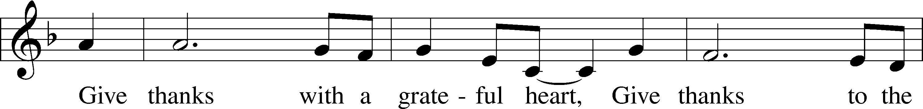
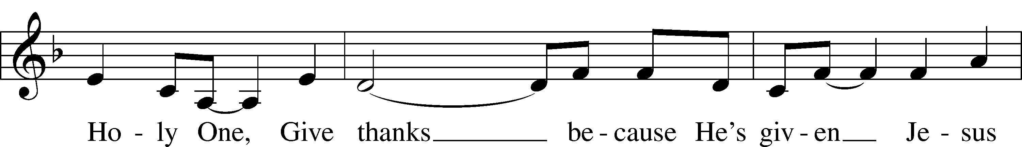
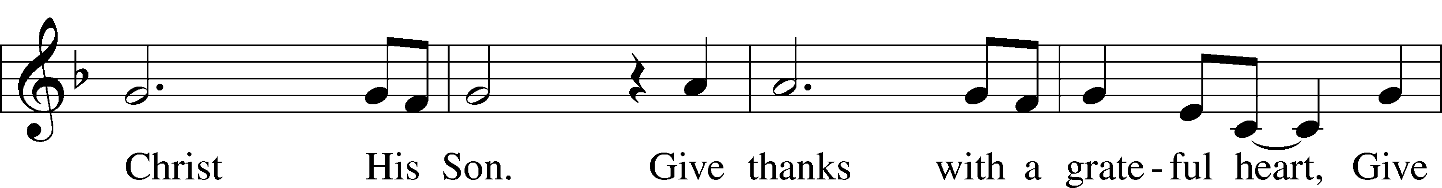
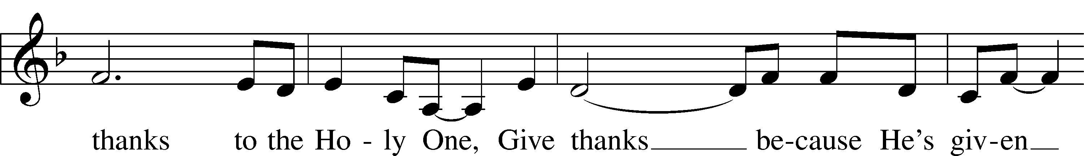
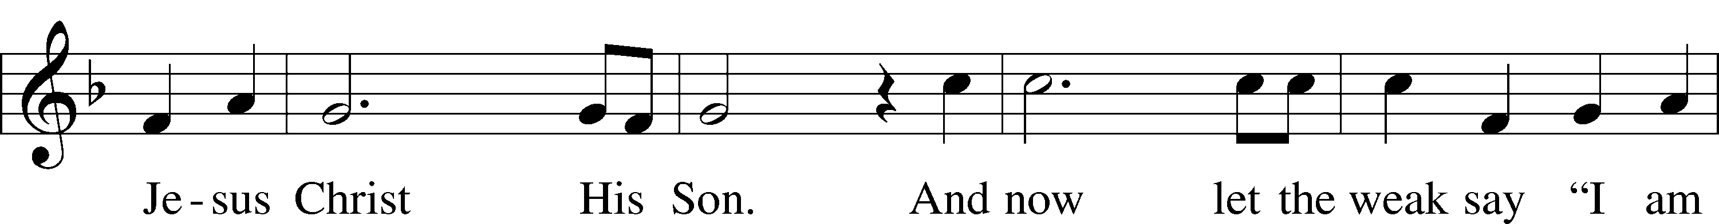
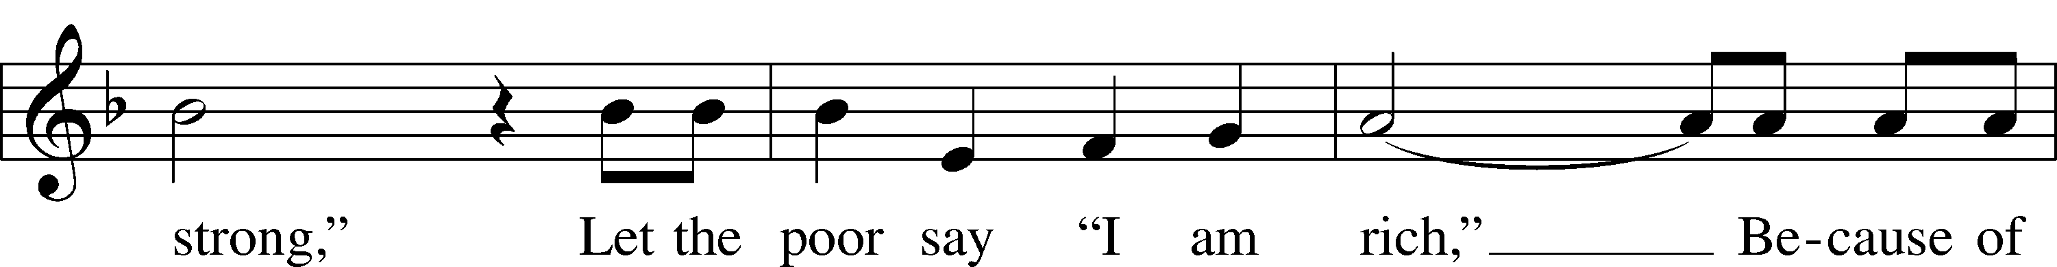
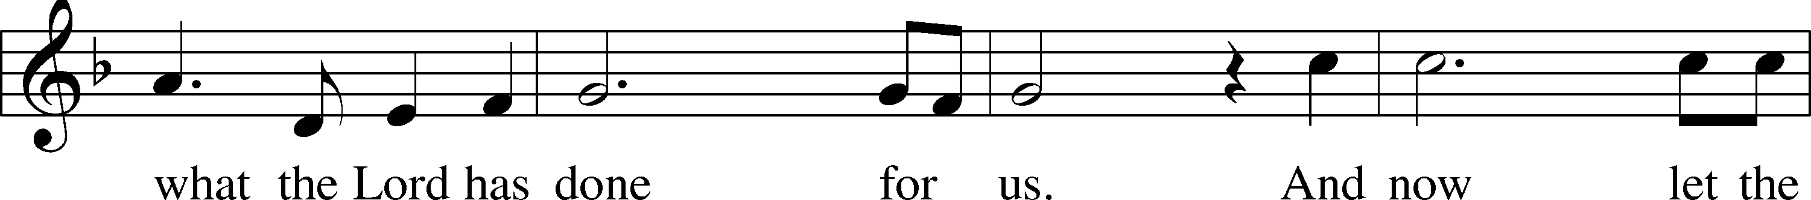
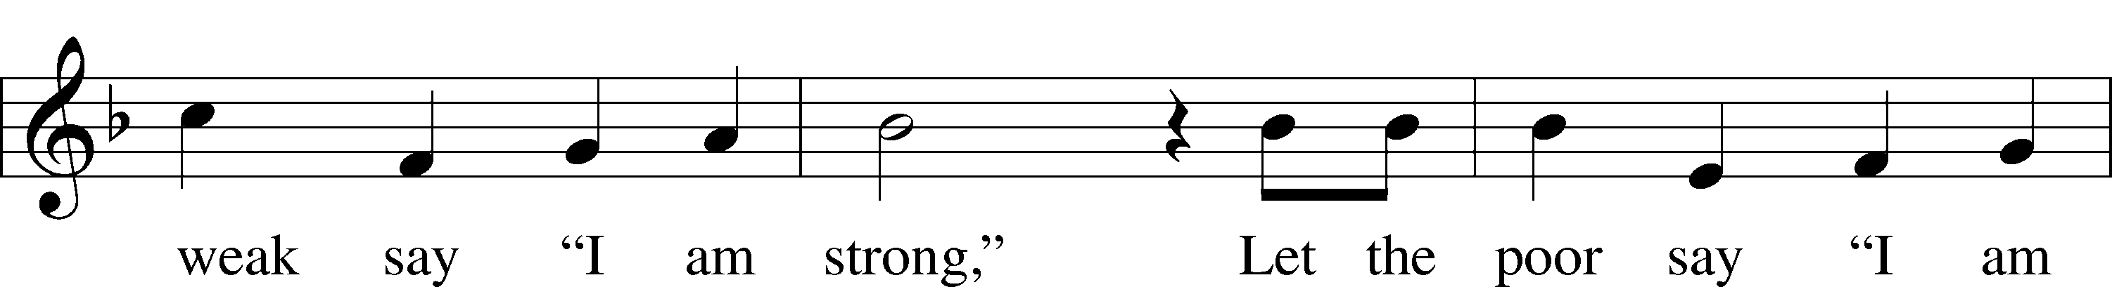

Continued on next page
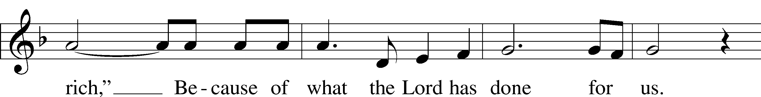
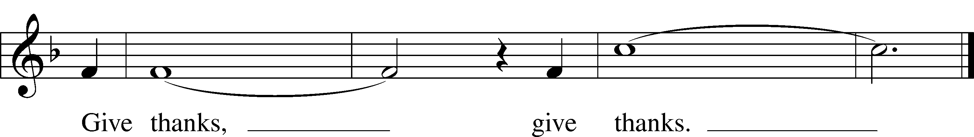

Text and tune: Henry Smith, 1952
Text and tune: © 1978 Integrity’s Hosanna! Music. Used by permission: LSB Hymn License no. 110002537

Please stand as able

CONFESSION and ABSOLUTION
The sign of the cross may be made by all in remembrance of their Baptism.

P In the name of the Father and of the T Son and of the Holy Spirit.
C Amen.
P Our help is in the name of the Lord,
C who made heaven and earth.
P If You, O Lord, kept a record of sins, O Lord, who could stand?
C But with You there is forgiveness; therefore, You are feared.
P Since we are gathered to hear God’s Word, call upon Him in prayer and praise, and receive the body and blood of our Lord Jesus Christ in the fellowship of this altar, let us first consider our unworthiness and confess before God and one another that we have sinned in thought, word, and deed, and that we cannot free ourselves from our sinful condition. Together as His people let us take refuge in the infinite mercy of God, our heavenly Father, seeking His grace for the sake of Christ, and saying: God, be merciful to me, a sinner.
C Almighty God, have mercy upon us, forgive us our sins, and lead us to everlasting life. Amen.

P Almighty God in His mercy has given His Son to die for you and for His sake forgives you all your sins. As a called and ordained servant of Christ, and by His authority, I therefore forgive you all your sins in the name of the Father and of the T Son and of the Holy Spirit.
C Amen.

SERVICE OF THE WORD
INTROIT
P It is God who executes judgment,
putting down one and lifting up another.
C We give thanks to you, O God; we give thanks, for your name is near.
We recount your wondrous deeds.
P At the set time that I appoint
I will judge with equity.
C For not from the east or from the west
and not from the wilderness comes lifting up.
P But I will declare it forever;
I will sing praises to the God of Jacob.
A Glory be to the Father and to the Son
and to the Holy Spirit;
as it was in the beginning,
is now, and will be forever. Amen.
P It is God who executes judgment,
putting down one and lifting up another.

KYRIE LSB 204
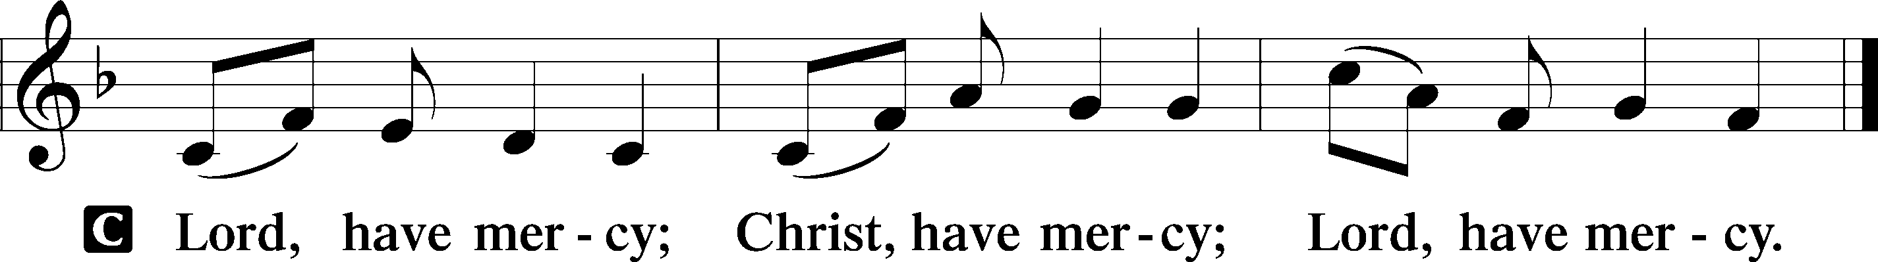

HYMN OF PRAISE
GLORIA IN EXCELSIS LSB 204
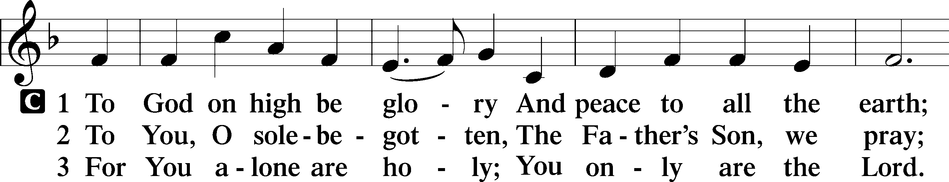
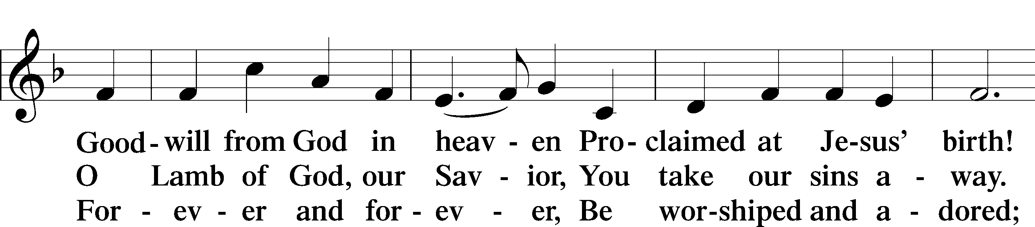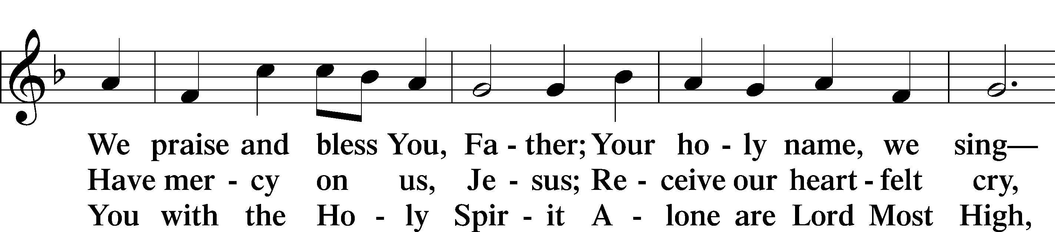
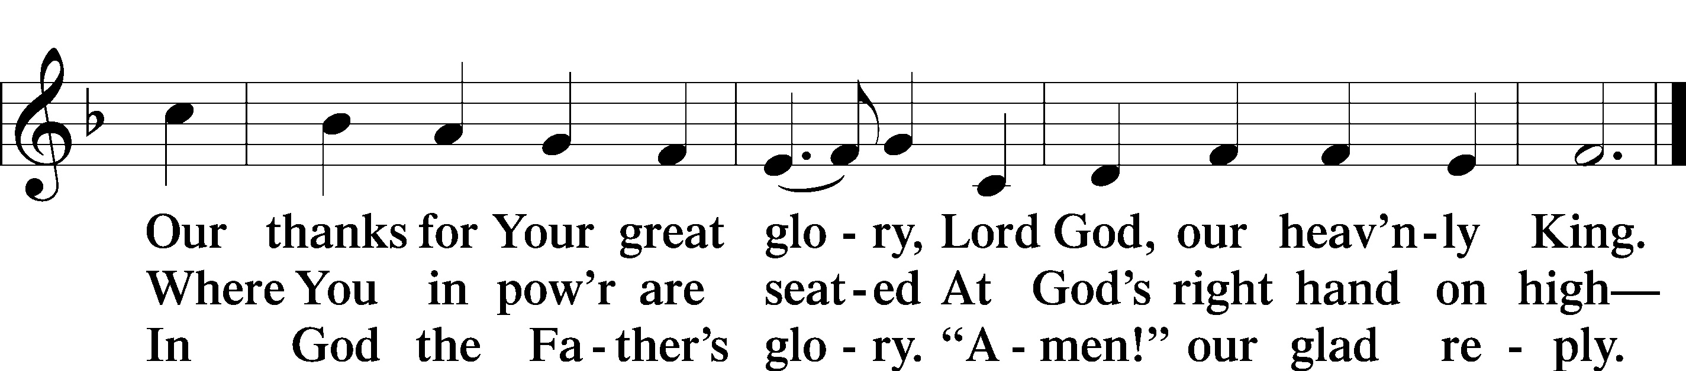
Text: Stephen P. Starke

SALUTATION AND COLLECT OF THE DAY
P The Lord be with you.
C And also with you.
P Let us pray.
Merciful Lord, cleanse and defend Your Church by the sacrifice of Christ. United with Him in Holy Baptism, give us grace to receive with thanksgiving the fruits of His redeeming work and daily follow in His way; through the same Jesus Christ, Your Son, our Lord, who lives and reigns with You and the Holy Spirit, one God, now and forever.
C Amen.

Please be seated
OLD TESTAMENT READING Proverbs 25:2–10
²It is the glory of God to conceal things,
but the glory of kings is to search things out.
³As the heavens for height, and the earth for depth,
so the heart of kings is unsearchable.
⁴Take away the dross from the silver,
and the smith has material for a vessel;
⁵take away the wicked from the presence of the king,
and his throne will be established in righteousness.
⁶Do not put yourself forward in the king’s presence
or stand in the place of the great,
⁷for it is better to be told, “Come up here,”
than to be put lower in the presence of a noble.
What your eyes have seen
⁸do not hastily bring into court,
for what will you do in the end,
when your neighbor puts you to shame?
⁹Argue your case with your neighbor himself,
and do not reveal another’s secret,
¹⁰lest he who hears you bring shame upon you,
and your ill repute have no end.
P This is the Word of the Lord.
C Thanks be to God.

EPISTLE Hebrews 13:1–17
¹Let brotherly love continue. ²Do not neglect to show hospitality to strangers, for thereby some have entertained angels unawares. ³Remember those who are in prison, as though in prison with them, and those who are mistreated, since you also are in the body. ⁴Let marriage be held in honor among all, and let the marriage bed be undefiled, for God will judge the sexually immoral and adulterous. ⁵Keep your life free from love of money, and be content with what you have, for he has said, “I will never leave you nor forsake you.” ⁶So we can confidently say,
“The Lord is my helper;
I will not fear;
what can man do to me?
⁷Remember your leaders, those who spoke to you the word of God. Consider the outcome of their way of life, and imitate their faith. ⁸Jesus Christ is the same yesterday and today and forever. ⁹Do not be led away by diverse and strange teachings, for it is good for the heart to be strengthened by grace, not by foods, which have not benefited those devoted to them. ¹⁰We have an altar from which those who serve the tent have no right to eat. ¹¹For the bodies of those animals whose blood is brought into the holy places by the high priest as a sacrifice for sin are burned outside the camp. ¹²So Jesus also suffered outside the gate in order to sanctify the people through his own blood. ¹³Therefore let us go to him outside the camp and bear the reproach he endured. ¹⁴For here we have no lasting city, but we seek the city that is to come. ¹⁵Through him then let us continually offer up a sacrifice of praise to God, that is, the fruit of lips that acknowledge his name. ¹⁶Do not neglect to do good and to share what you have, for such sacrifices are pleasing to God.
¹⁷Obey your leaders and submit to them, for they are keeping watch over your souls, as those who will have to give an account. Let them do this with joy and not with groaning, for that would be of no advantage to you.

P This is the Word of the Lord.
C Thanks be to God.

Please stand as able

ALLELUIA AND VERSE
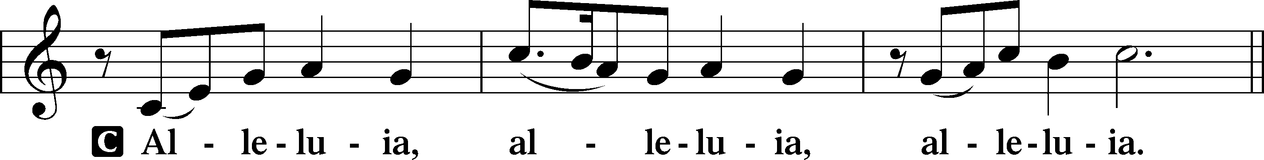
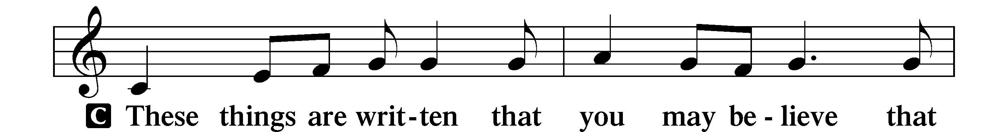
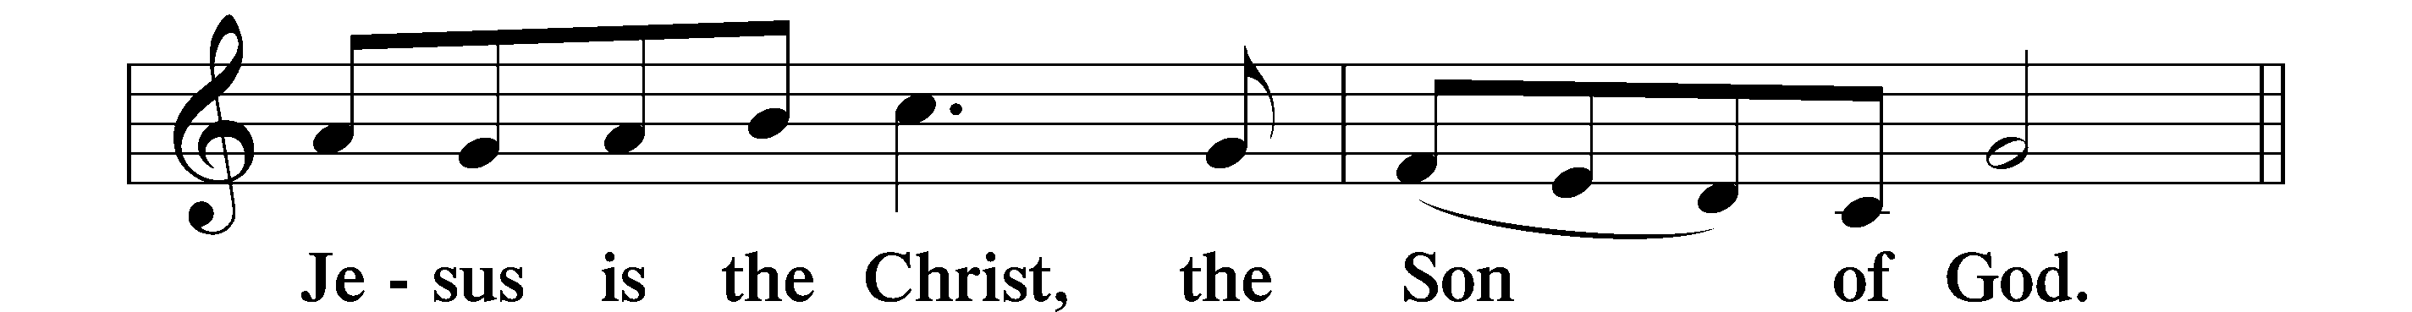
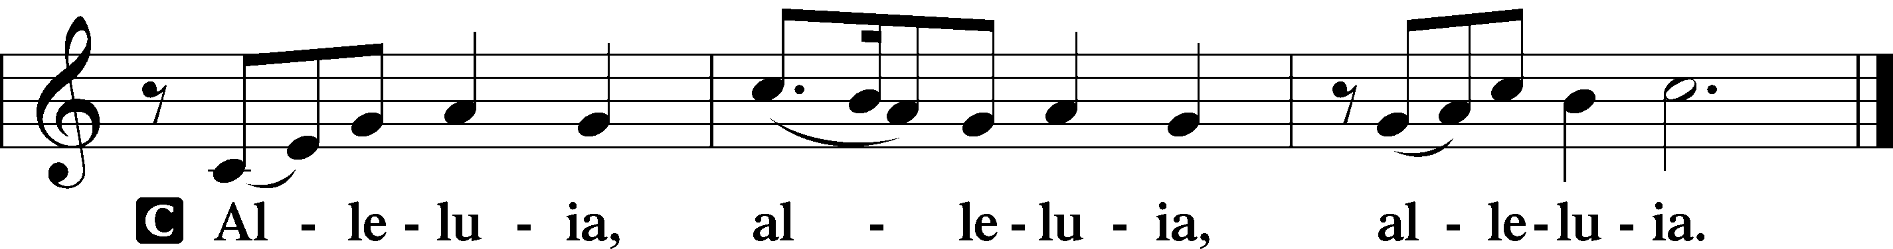

HOLY GOSPEL Luke 14:1–14
P The Holy Gospel according to St. Luke, the fourteenth chapter.
C Glory to You, O Lord.

¹One Sabbath, when [Jesus] went to dine at the house of a ruler of the Pharisees, they were watching him carefully. ²And behold, there was a man before him who had dropsy. ³And Jesus responded to the lawyers and Pharisees, saying, “Is it lawful to heal on the Sabbath, or not?” ⁴But they remained silent. Then he took him and healed him and sent him away. ⁵And he said to them, “Which of you, having a son or an ox that has fallen into a well on a Sabbath day, will not immediately pull him out?” ⁶And they could not reply to these things.
⁷Now he told a parable to those who were invited, when he noticed how they chose the places of honor, saying to them, ⁸“When you are invited by someone to a wedding feast, do not sit down in a place of honor, lest someone more distinguished than you be invited by him, ⁹and he who invited you both will come and say to you, ‘Give your place to this person,’ and then you will begin with shame to take the lowest place. ¹⁰But when you are invited, go and sit in the lowest place, so that when your host comes he may say to you, ‘Friend, move up higher.’ Then you will be honored in the presence of all who sit at table with you. ¹¹For everyone who exalts himself will be humbled, and he who humbles himself will be exalted.”
¹²He said also to the man who had invited him, “When you give a dinner or a banquet, do not invite your friends or your brothers or your relatives or rich neighbors, lest they also invite you in return and you be repaid. ¹³But when you give a feast, invite the poor, the crippled, the lame, the blind, ¹⁴and you will be blessed, because they cannot repay you. You will be repaid at the resurrection of the just.”

P This is the Gospel of the Lord.
C Praise to You, O Christ.

NICENE CREED
C I believe in one God,
the Father Almighty,
maker of heaven and earth
and of all things visible and invisible.
And in one Lord Jesus Christ,
the only-begotten Son of God,
begotten of His Father before all worlds,
God of God, Light of Light,
very God of very God,
begotten, not made,
being of one substance with the Father,
by whom all things were made;
who for us men and for our salvation came down from heaven
and was incarnate by the Holy Spirit of the virgin Mary
and was made man;
and was crucified also for us under Pontius Pilate.
He suffered and was buried.
And the third day He rose again according to the Scriptures
and ascended into heaven
and sits at the right hand of the Father.
And He will come again with glory to judge both the living and the dead,
whose kingdom will have no end.
And I believe in the Holy Spirit,
the Lord and giver of life,
who proceeds from the Father and the Son,
who with the Father and the Son together is worshiped and glorified,
who spoke by the prophets.
And I believe in one holy Christian and apostolic Church,
I acknowledge one Baptism for the remission of sins,
and I look for the resurrection of the dead
and the life T of the world to come. Amen.

Please be seated

ALL GOD’S CHILDREN – TALK

SERMON HYMN
We Give Thee But Thine Own LSB 781
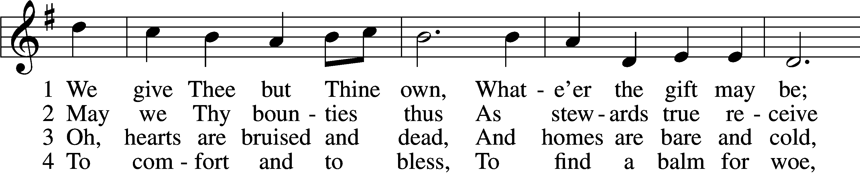
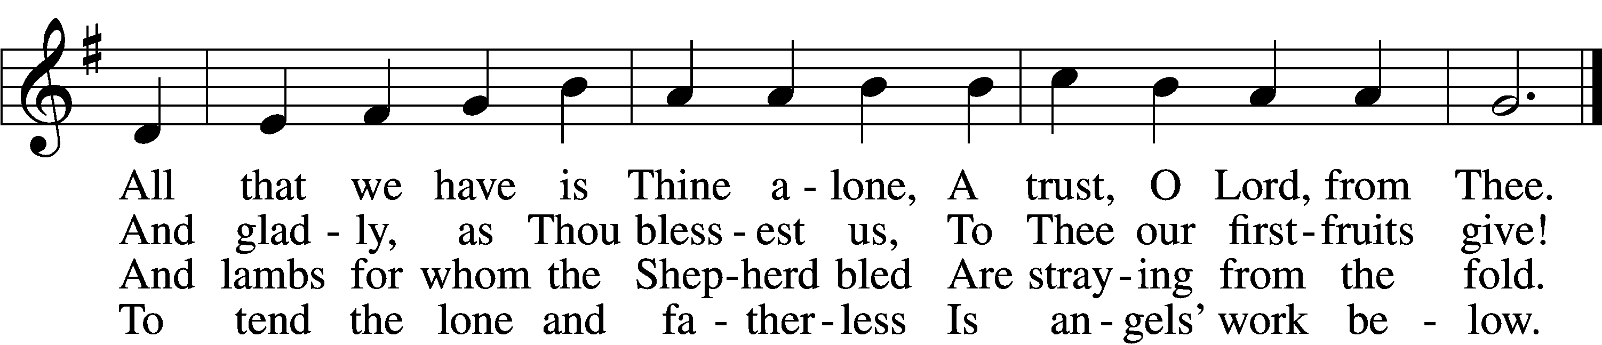

5 The captive to release, 6 And we believe Thy Word,
To God the lost to bring, Though dim our faith may be
To teach the way of life and peace, Whate’er for Thine we do, O Lord,
It is a Christ-like thing. We do it unto Thee

Text: William W. How, 1823–97
Tune: William H. Monk, 1823–89
Text and tune: Public domain

SERMON

Please stand as able

PRAYER of the CHURCH
After each Segment:
P Lord, in Your Mercy,
C Hear our Prayer.
After Final Segment:
P Hear us as we pray in His name and as He has taught us:

LORD’S PRAYER
C Our Father who art in heaven,
hallowed be Thy name,
Thy kingdom come,
Thy will be done on earth
as it is in heaven;
give us this day our daily bread;
and forgive us our trespasses
as we forgive those
who trespass against us;
and lead us not into temptation,
but deliver us from evil.
For Thine is the kingdom
and the power and the glory
forever and ever. Amen.

SERVICE of the SACRAMENT

PREFACE LSB 208
P The Lord be with you.
C And also with you.
P Lift up your hearts.
C We lift them to the Lord.
P Let us give thanks to the Lord our God.
C It is right to give Him thanks and praise.
P It is truly good, right, and salutary that we should at all times and in all places give thanks to You, O Lord, holy Father, almighty and everlasting God, for the countless blessings You so freely bestow on us and all creation. Above all, we give thanks for Your boundless love shown to us when You sent Your only-begotten Son, Jesus Christ, into our flesh and laid on Him our sin, giving Him into death that we might not die eternally. Because He is now risen from the dead and lives and reigns to all eternity, all who believe in Him will overcome sin and death and will rise again to new life. Therefore with angels and archangels and with all the company of heaven we laud and magnify Your glorious name, evermore praising You and singing:

SANCTUS LSB 208
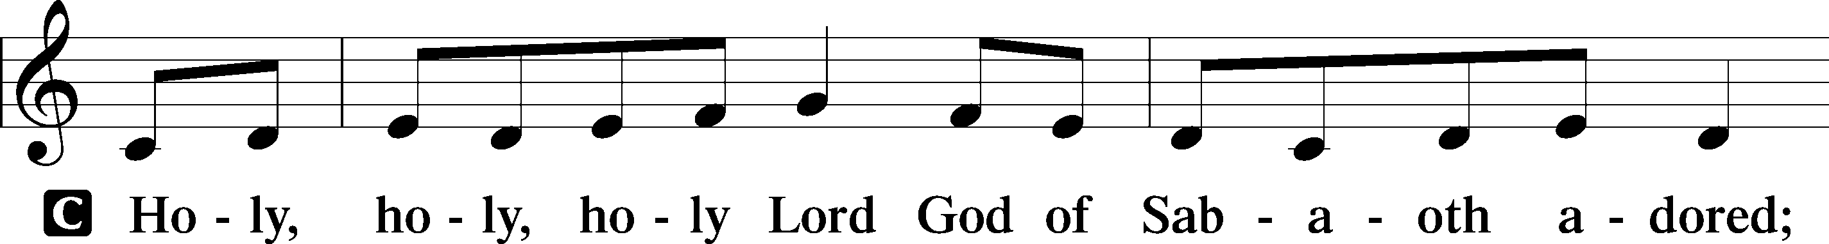
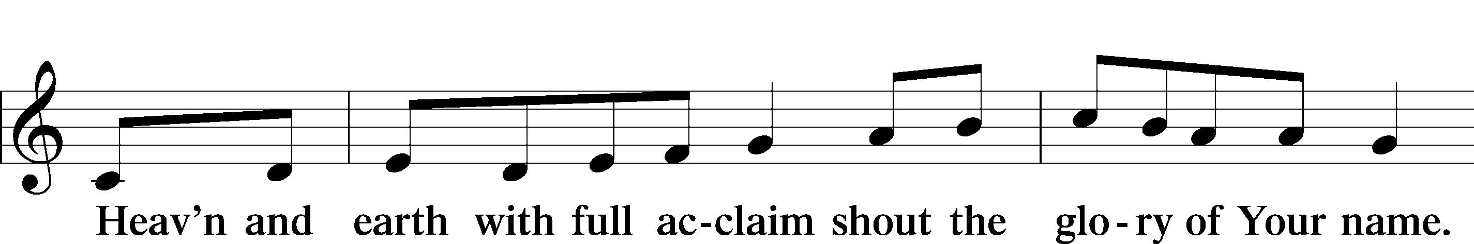
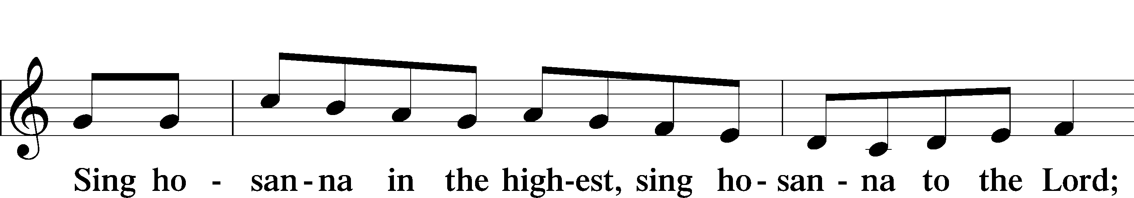
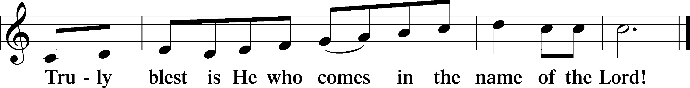

THE WORDS OF OUR LORD
P Our Lord Jesus Christ, on the night when He was betrayed, took bread, and when He had given thanks, He broke it and gave it to the disciples and said: “Take, eat; this is My T body, which is given for you. This do in remembrance of Me.”
In the same way also, He took the cup after supper, and when He had given thanks, He gave it to them, saying: “Drink of it, all of you; this cup is the New Testament in My T blood, which is shed for you for the forgiveness of sins. This do, as often as you drink it, in remembrance of Me.”

PAX DOMINI
P The peace of the Lord be with you always.
C Amen.

AGNUS DEI
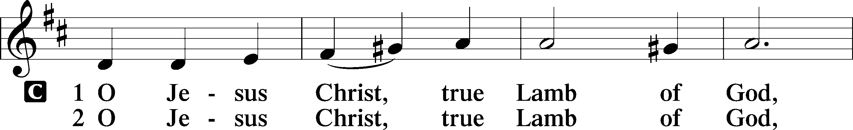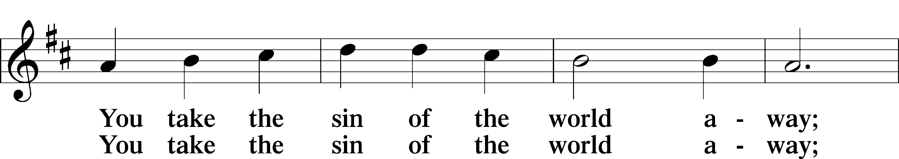
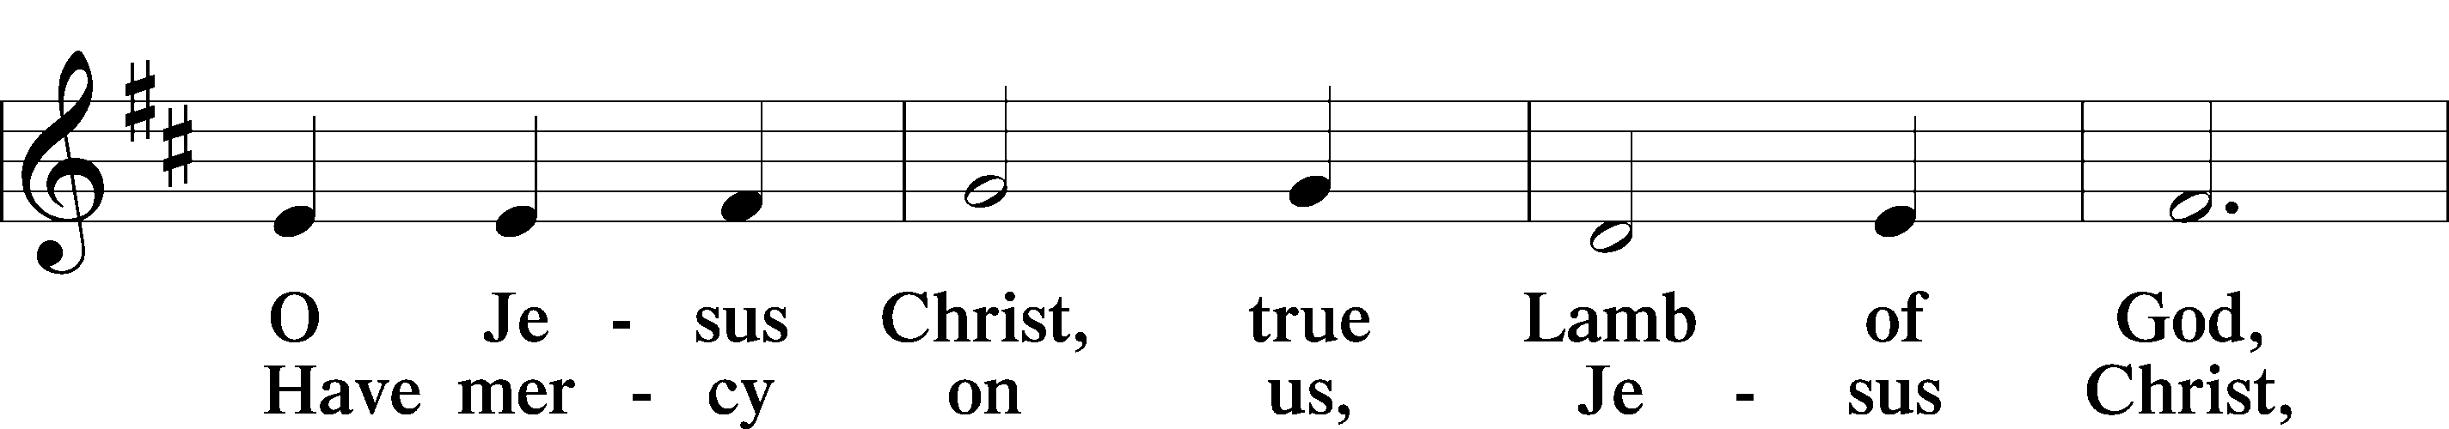
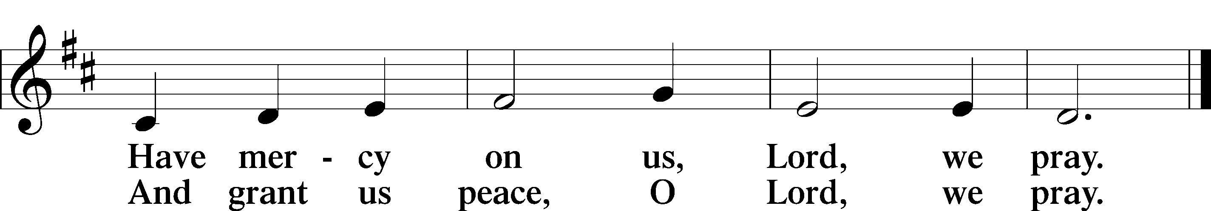

Please be seated
DISTRIBUTION
The pastor and those who assist him receive the body and blood of Christ first, then Communion will be served at the rail. Ushers will help direct you forward via the center aisle; please return to your seats via the side aisles. Gluten-free bread is available for those who need it, as is non-alcoholic grape juice. Simply request either when you come forward to receive Communion.

DISTRIBUTION HYMN
Lord of Glory, You Have Bought Us LSB 851
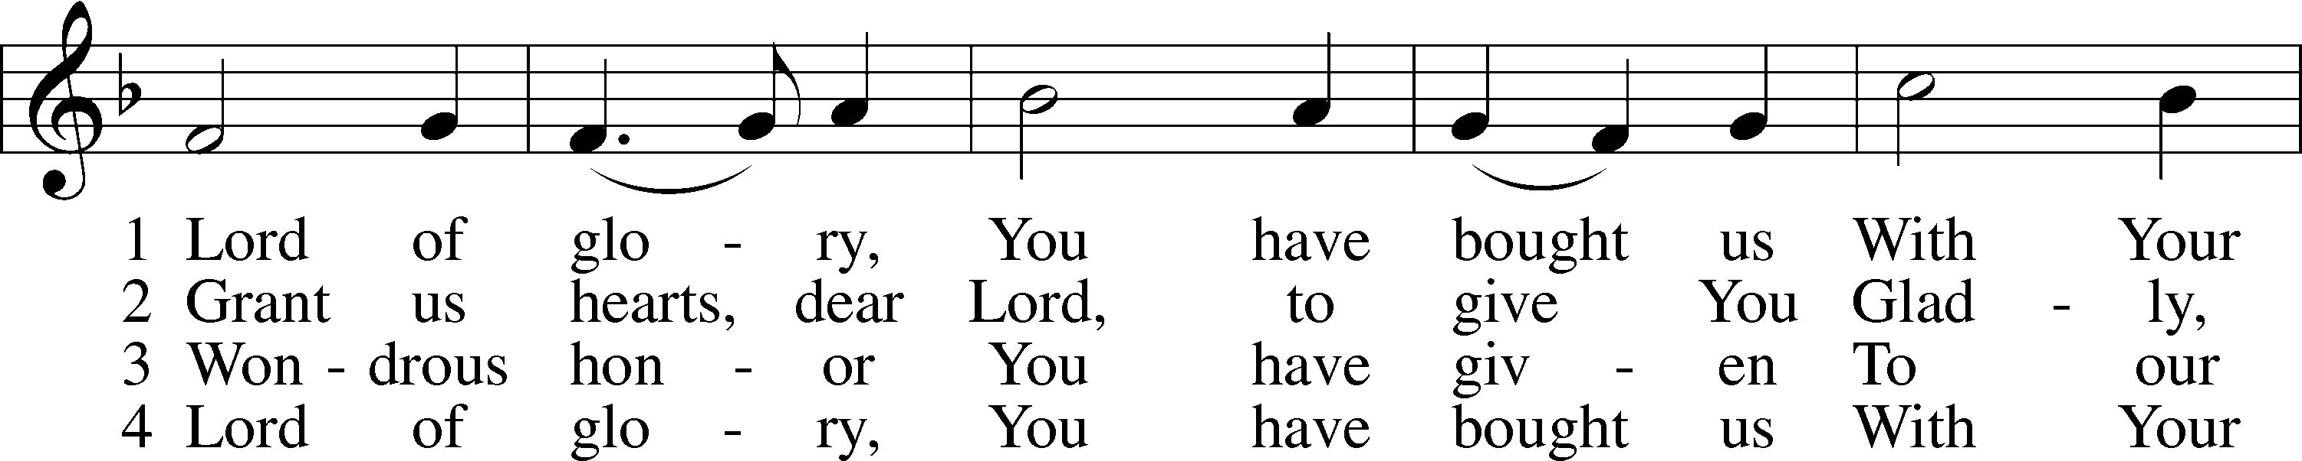
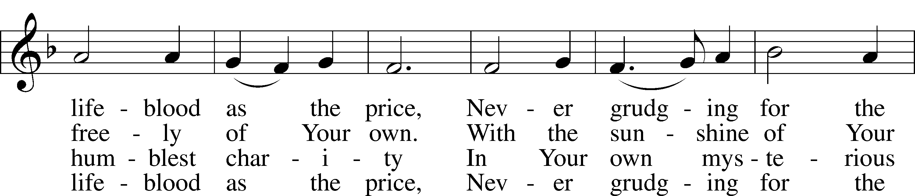
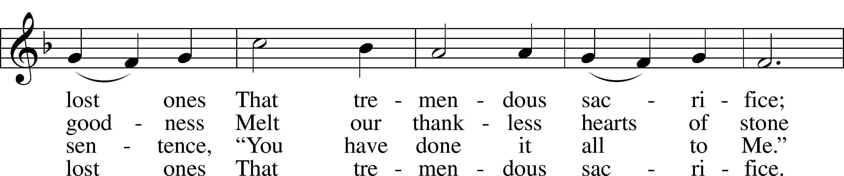
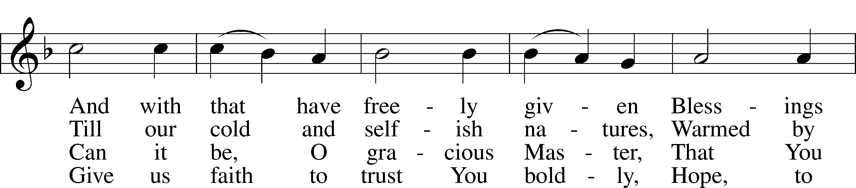
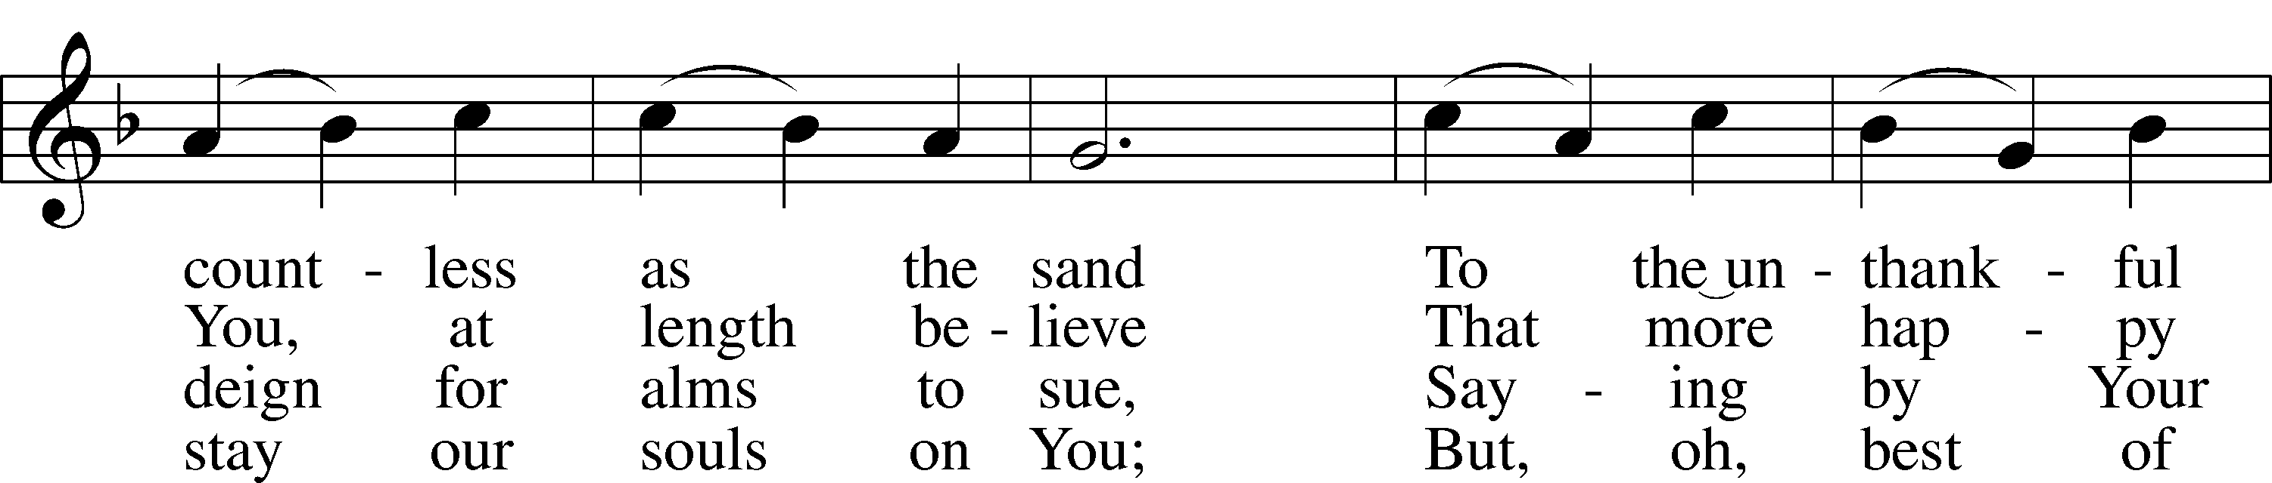
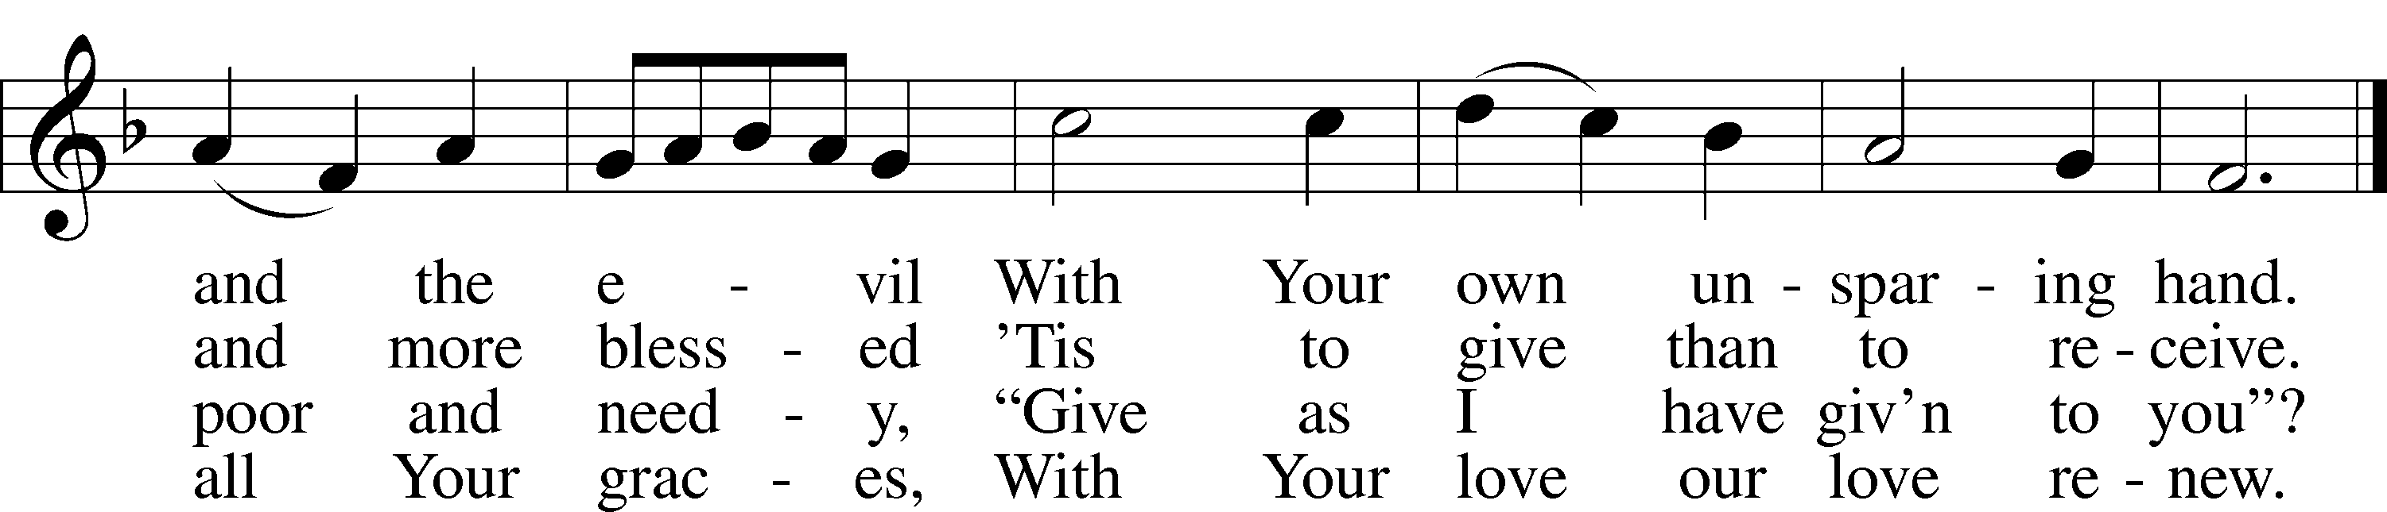
Text: Eliza S. Alderson, 1818–89, alt. Tune: Rowland H. Prichard, 1811–87 Text and tune: Public domain

Please stand as able

NUNC DIMITTIS LSB 211
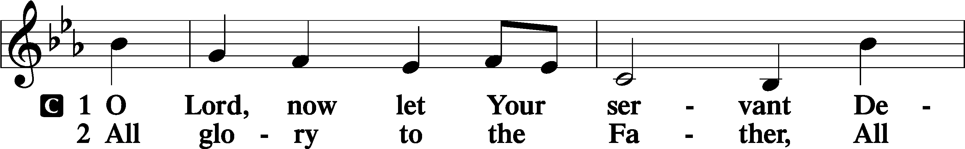
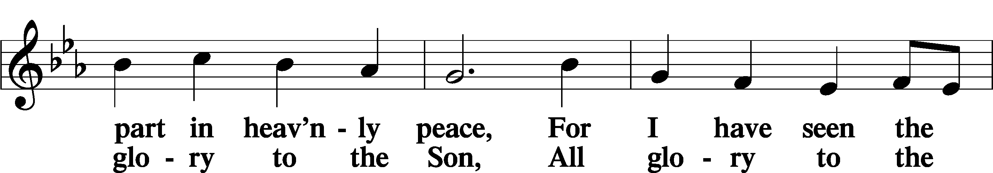
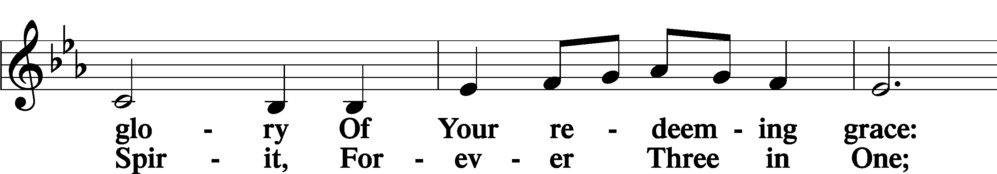
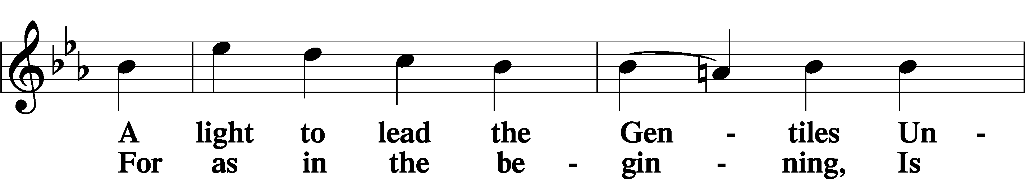
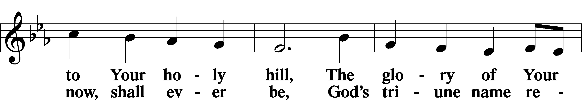
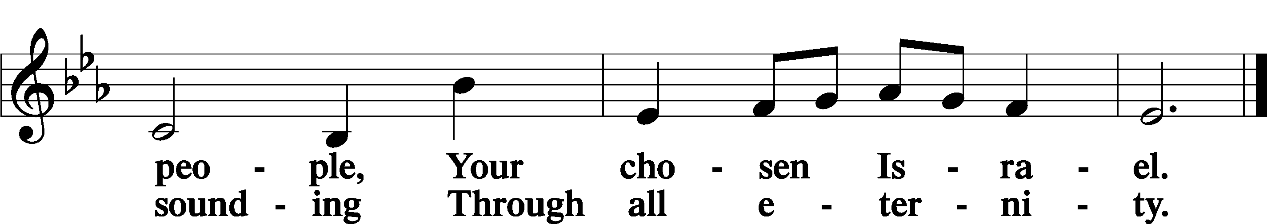

POST COMMUNION COLLECT
P Let us pray.
O God the Father, the fountain and source of all goodness, who in loving-kindness sent Your only-begotten Son into the flesh, we thank You that for His sake You have given us pardon and peace in this Sacrament, and we ask You not to forsake Your children but always to rule our hearts and minds by Your Holy Spirit that we may be enabled constantly to serve You; through Jesus Christ, Your Son, our Lord, who lives and reigns with You and the Holy Spirit, one God, now and forever.
C Amen.

BENEDICAMUS LSB 212
P Let us bless the Lord.
C Thanks be to God.
BENEDICTION
P The Lord bless you and keep you.
The Lord make His face shine on you and be gracious to you.
The Lord look upon you with favor and T give you peace.
C Amen.

Please be seated
CLOSING HYMN
Praise and Thanksgiving LSB 789
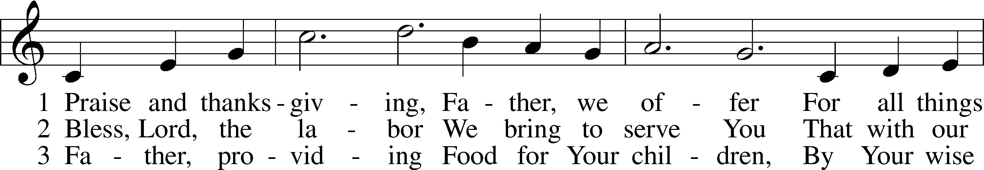
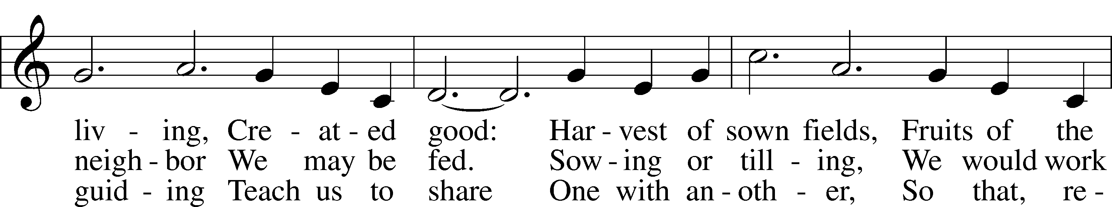
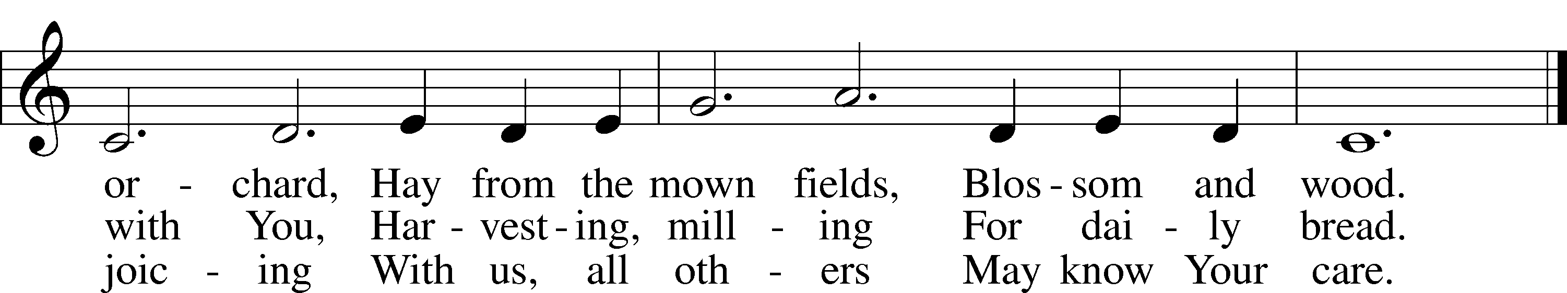

Text: Albert F. Bayly, 1901–84
Tune: Gaelic, 19th cent.
Text: © 1987 Oxford University Press. Used by permission: LSB Hymn License no. 110002537
Tune: Public domain

ANNOUNCEMENTS and SENDING WORDS
P We go to live for Jesus!
C We go to share His love!

Acknowledgments
Unless otherwise indicated, Scripture quotations are from the ESV® Bible (The Holy Bible, English Standard Version®),
copyright © 2001 by Crossway, a publishing ministry of Good News Publishers. Used by permission. All rights reserved.
Created by Lutheran Service Builde
SERVING IN GOD’S HOUSE TODAY
Pastor: Rev. Ken Bernthal
Elder: Ken Mertz
Ushers: Tom Raithel, Linda West
Greeters: Appold Family
Counters: Larry Whitney, Wendell Smith
Coffee Servers: Paul & Karen Schneider
Altar Care: Nancy Ely
Piano/Organ: Tom & Jean Beach
Children’s Talk Nancy Ely
Post-Service Bible Study to resume on September 11th.
PRAYERS
Please contact the office with updates to the prayer list. People will remain on the prayer list for 4 weeks before being removed. If they need to remain on the list, please keep Elaine informed and of any updates. This will help us to have a more accurate list. Thanks for your cooperation.
Those who continue to grieve the passing of loved ones, The Family Dolores Mouch.and The Family of Dawn (Huff) Cottrell her mother Pegi passed away recently.
Those with upcoming surgery:
Those recovering from surgery: Joann Whitney.
Those with health concerns: Tiffany Amsdill, Hope Buchinger, Betsy Cook, Kay Gregg, Paul Kietzman, Hilda Koch, Pam & Eddie Martin (inlaws of Leslie Martin) Jennifer Martin, Ron Kwapis, Eleanor Raether, Beth Smith, and Judi Stutzman.
Those diagnosed with cancer: Leah Eicher, Rachel Frisch, Janice Knoellinger, Leslie Martin, Brian Morgan, Hope Osantowski, and John Stutzman.
Those under Hospice Home Care: Ken Williamson, Jim (Joann Whitney’s brother-in law).
Pam & Eddie Martin (inlaws of Leslie Martin)
Prayers for students heading beck to college.

BIRTHDAYS:
8/29 Paula Beach 9/2 Elaine Raschke
8/31 Roxy Mohr 9/2 Shelia Trahin
8/31 Isabel Wingo 9/3 Richard Shafer
9/1 Hilda Koch 9/3 Sophia Woiderski

ANNIVERSARIES
8/30 Mark & Julie Hull

MESSAGES

ALTAR FLOWERS today are given to the glory of God by Bill and Terry Stiles in celebration of their 40th anniversary on August 21st.
MEMBER & GUEST CARDS: If you have not filled out a member/guest card, please take the time to fill one out and place it in the plate behind the back pews in our sanctuary.
GREETING CARDS If you are in need of some greeting cards, we carry an array of them. The card cabinet is in the hallway across from the library. The cost of the cards is posted on the cabinet. The money collected from the cards goes to LWML to help support Missions.
CHURCH EXTENSION FUND has proven investment products with measurable results. Since 1901, through dedicated Christian financial management, CEF is focused on funding the needs of Michigan District congregations. (Proven, Dedicated, Focused)
For more information, contact (Congregation Representative and telephone number) or call 800-242-3944.
WEDNESDAY MORNING BIBLE STUDY will resume on September 14th at 10am.
LARGE PRINT WORSHIP FOLDERS: We now have large print worship folders available on the table where the offerings are put. Please feel free to take one.
REV. TIM WELLS & SHONDA will be visiting Trinity on August 31st.

CHOIR: will start up again in the church on Monday September 12^{th.}
KUT-UPS will start up again beginning Monday September 12 at 10:00 a.m. So, mark your calendars and let's get started.

THIS WEEK AT TRINITY

August 28 Sunday
9:00 am Worship Service
Noisy Offering
10:00 am Fellowship & Coffee Hour
August 29 Monday
August 30 Tuesday
August 31 Wednesday
Rev. Tim & Shonda Wells will visit with Trinity
September 1 Thursday
September 2 Friday
September 3 Saturday
10:00 am Stephen Ministry Peer Supervision meeting
September 4 Sunday Labor Day Weekend
9:00 am Worship Service
10:00 am Fellowship & Coffee Hour

SERVING IN GOD’S HOUSE NEXT SUNDAY 9/4/2022
Pastor: Rev. Paul Schneider
Elder: Tim Arner
Ushers: Larry & Joann Whitney
Greeters: Tina VanTil, Nancy Ely
Counters: Donna Cottrell, La Verne Scheiterlein
Coffee Servers: Bob & Kathy Erat
Altar Care: Karen Schneider
Virtual Organist: Bob Erat
Children’s Talk: Nancy Ely
Post-Service Bible Study to resume at 10:30am on September 11th.

